Welcome to Quartz Class
Autumn 2022
I am excited to be a part of Quartz Class’s learning journey this year and I look forward to working with you all through the coming year. In order for you to support your child at home, below is an outline of the curriculum areas we will be covering in the different subjects this term, as well as information regarding home learning (see final page). If you have any questions or queries, please do not hesitate to ask.
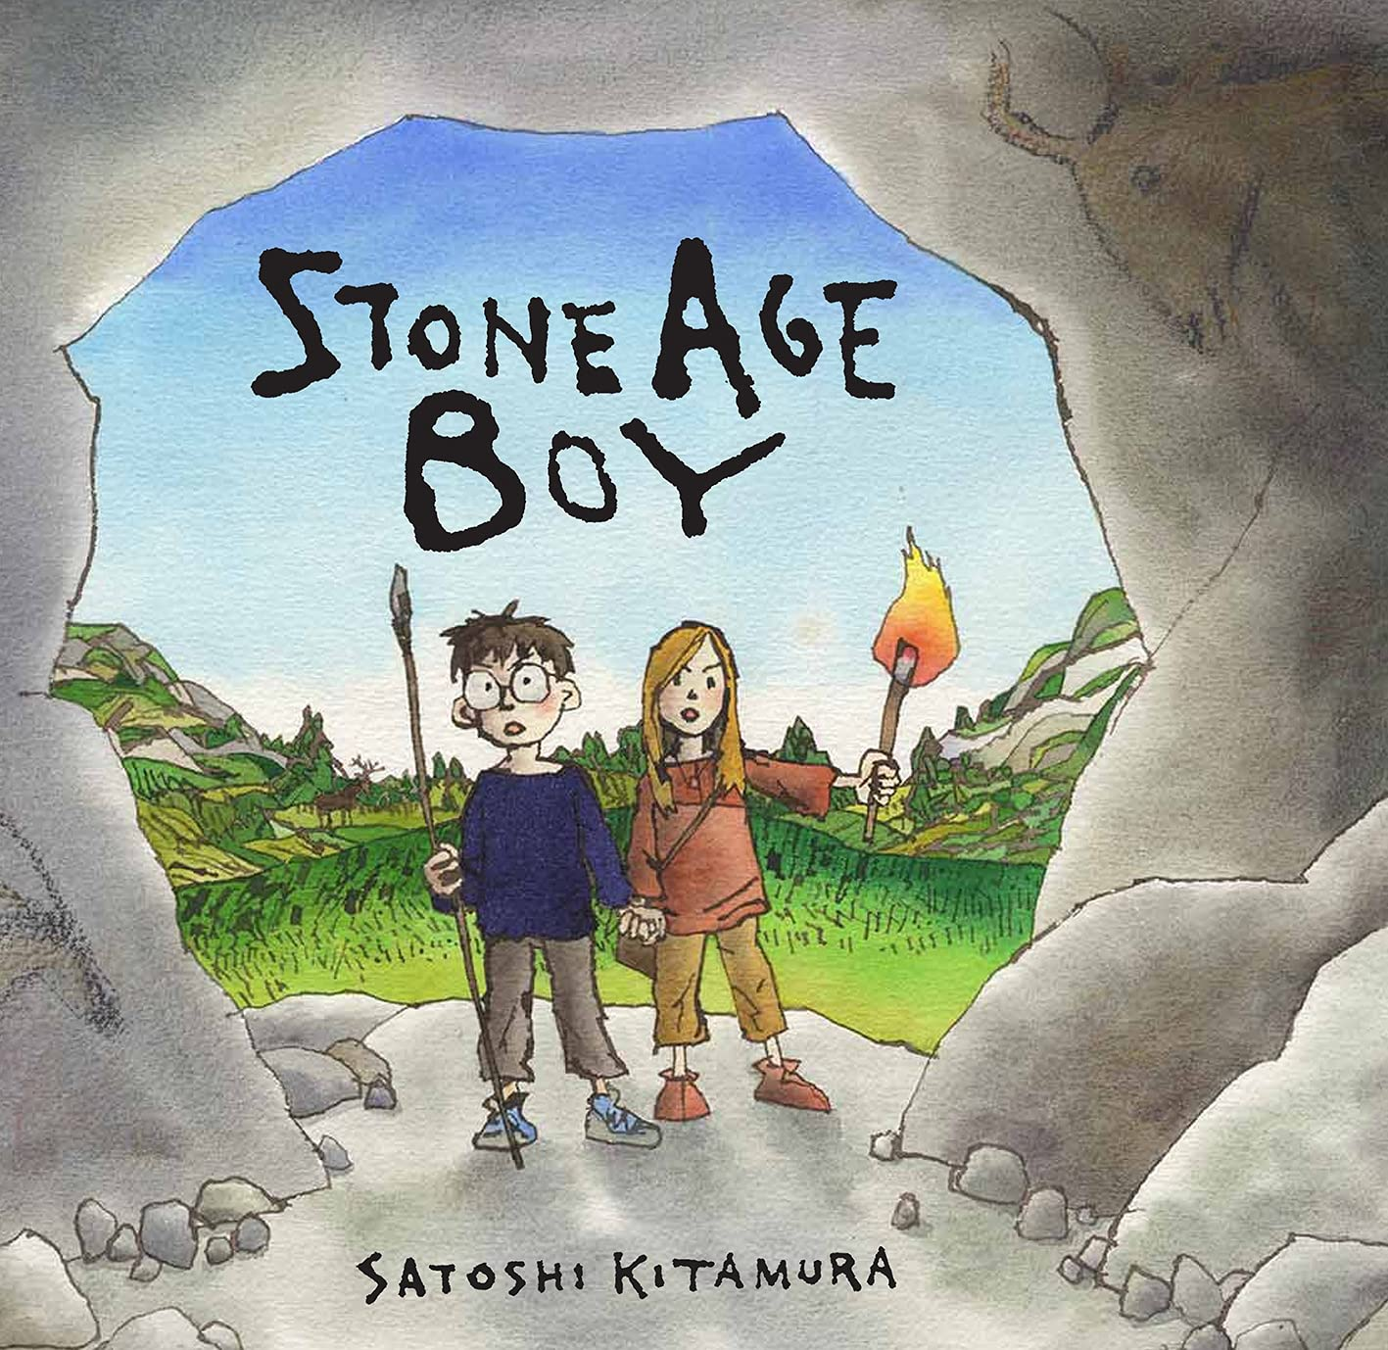
English
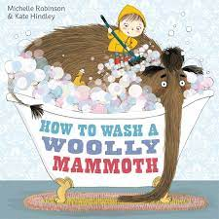
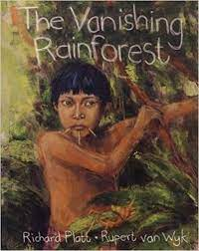
In English this term, we will be focusing on Setting descriptions, instruction writing and information texts. We will be using the texts, Stone Age Boy and Wild Girl to inspire our setting descriptions; we will be working on opening our sentences in a variety of ways, using higher level vocabulary and thinking about our senses to write precise and detailed setting descriptions. We will then move on to instructional writing inspired by the book How to Wash A Woolly Mammoth. During this unit of work, we will be focusing on our use of imperative verbs and prepositional language. Following on from this, we will be writing short information texts based on our History Topic of the Stone Age. During this unit of work, we will focus on the structure and layout of information texts as well as the use of formal language and technical vocabulary.
After half term, we will be using video stimuli and short stories to aid us in learning to accurately punctuate direct speech. We will then use the skills we learn to write our own story openings that include the use of direct speech. Later in the term, we will also be exploring discussion texts and balanced arguments particularly in relation to the rainforest and deforestation. We will consider the reasons for and against deforestation and use these to write our own discussion texts.
During our English lessons, we will be building upon our SPaG (Spelling, Punctuation and Grammar) knowledge by developing our understanding of sentence construction and word classes as well as improving our accuracy when using a wider variety of punctuation and appropriate determiners.
Reading
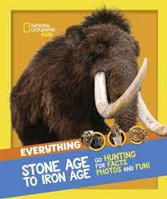
In school, we will have regular opportunities to read both fiction and non fiction texts individually and as a class. During reading lessons, we will be exploring various texts at a deeper level to build upon our inference and deduction skills as well as to broaden our vocabularies and understanding.
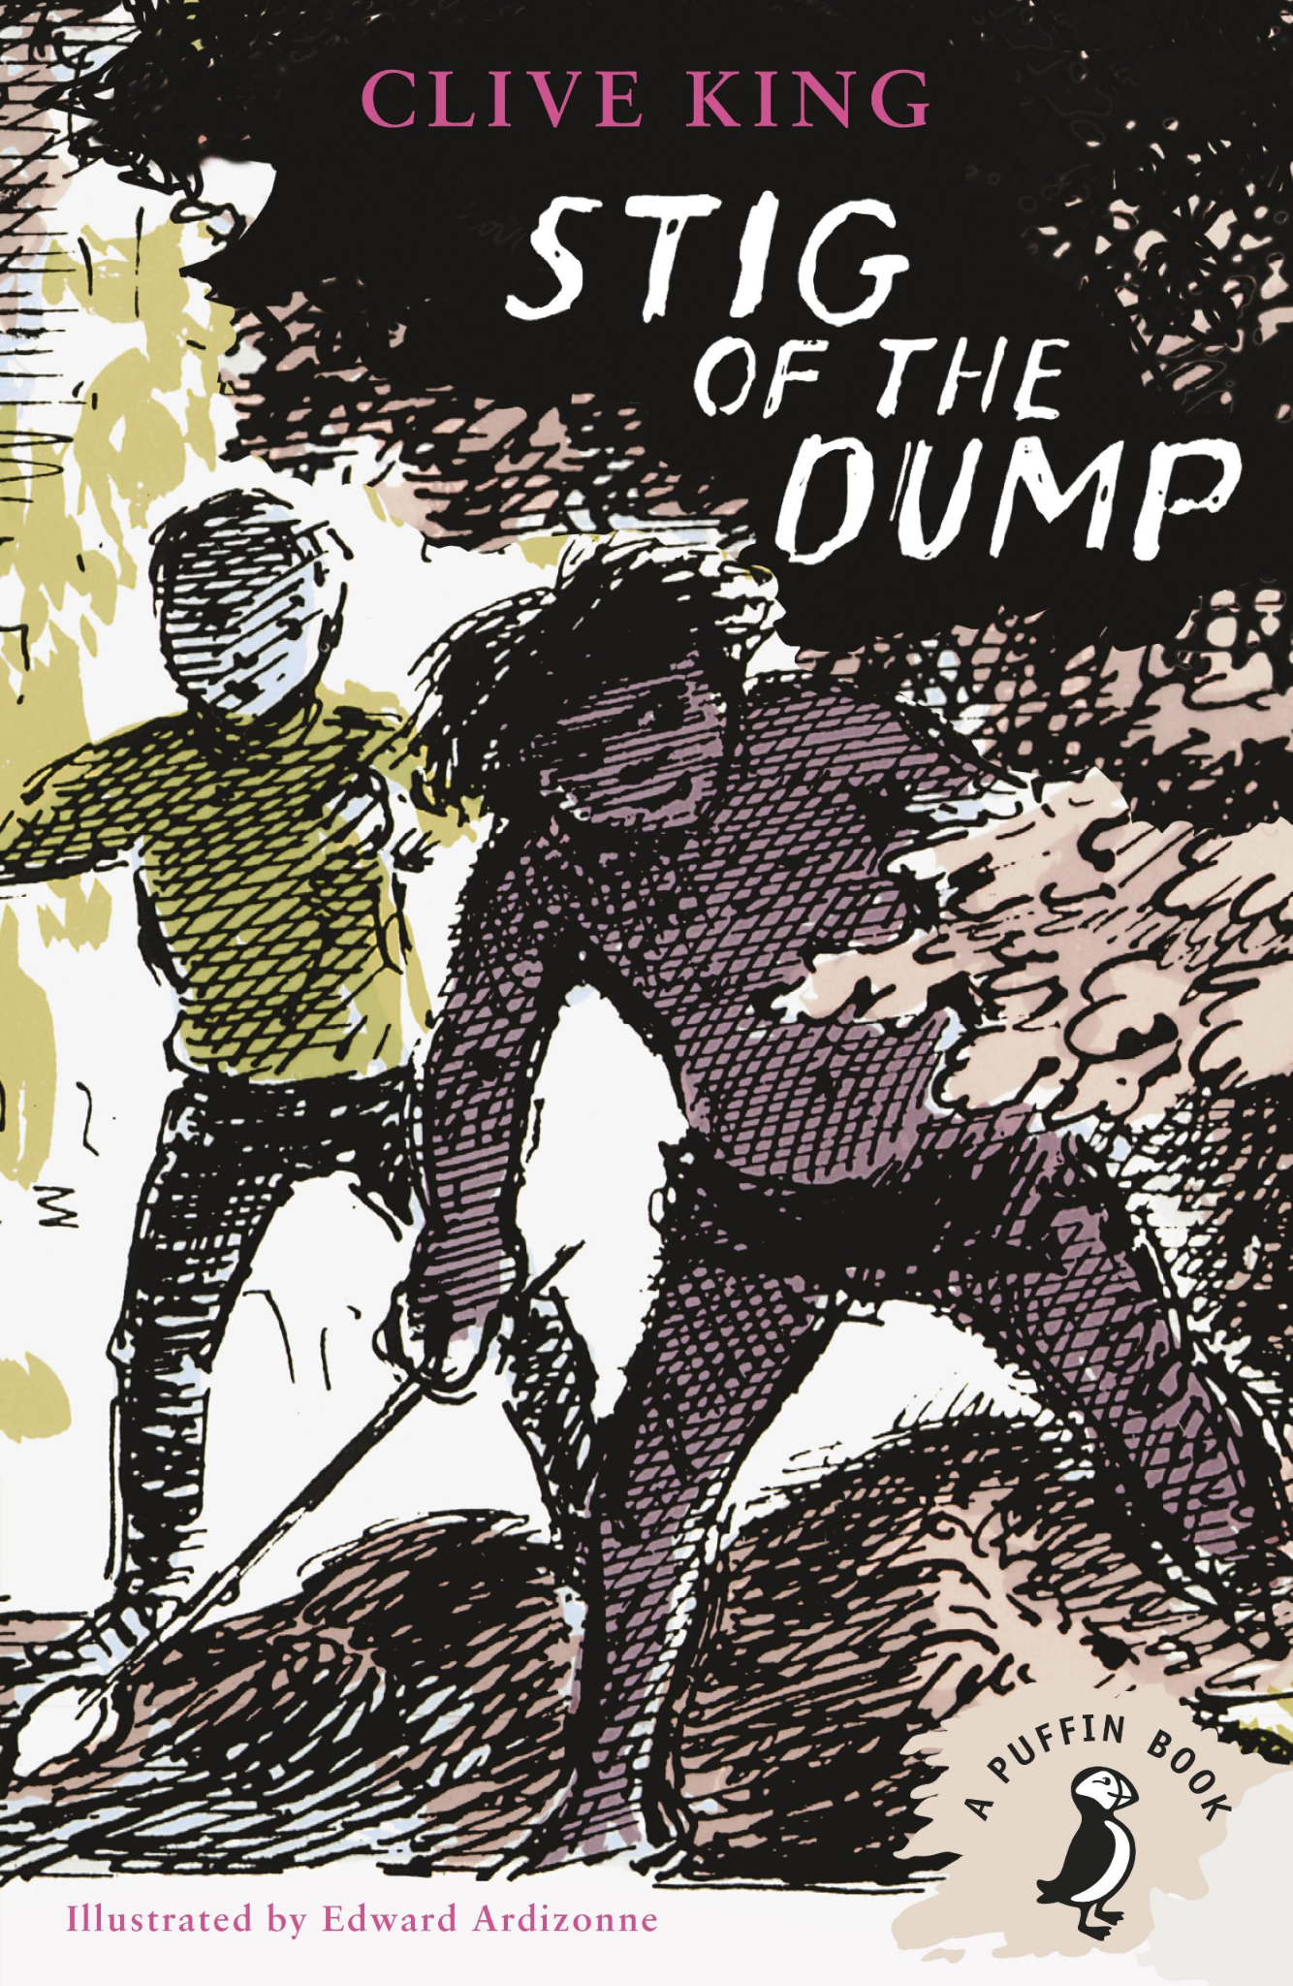
We will begin our guided reading lessons this term by reading The National Geographic: Everything Stone Age to Iron Age. During our guided reading lessons we will be focusing on recognising the features of a non-fiction text and using the contents and index pages as well as headings and subheadings to locate information. We will also be working on the skills or summarising and retrieval. We will be learning to accurately identify the key information within the text and ensure we include this when summarising. When working on our retrieval skills, we will be making sure we are locating information relevant to the question we are asked then recording information found in the text with accuracy.
After Half term, we will move away from Non-Fiction and onto a fiction text: Stig of the Dump, as part of our guided reading sessions. We will continue to work on our skills of retrieval as well as learn to make accurate predictions based upon details both stated and implied within a fiction text. We will also begin making inferences and justify these based on evidence from the text and learn to use the context of unfamiliar words to deduce their meaning. This is a particularly important skill as we begin to read texts with further higher level vocabulary.

Maths
In Maths this term, we will be starting off with a focus on exploring place value in numbers up to 1000. We will be partitioning and representing numbers in different ways using concrete, pictorial and abstract representations. We will also be learning to order and compare numbers by thinking carefully about their value and learning to find 1, 10 and 100 more or less than numbers up to 1000.
Following on from this we will be focusing on the four operations (addition, subtraction, multiplication and division.) We will begin by developing methods to add and subtract mentally with both speed and accuracy as well as using number lines, partitioning and visual representations for addition and subtraction. Following on from this, children will be introduced to the standard methods of laying out addition and subtraction calculations using up to 3-digit numbers. We will then move on to explore multiplication and division focusing in particular on using our 2s, 5s, 10s, 3s, 4s and 8s.
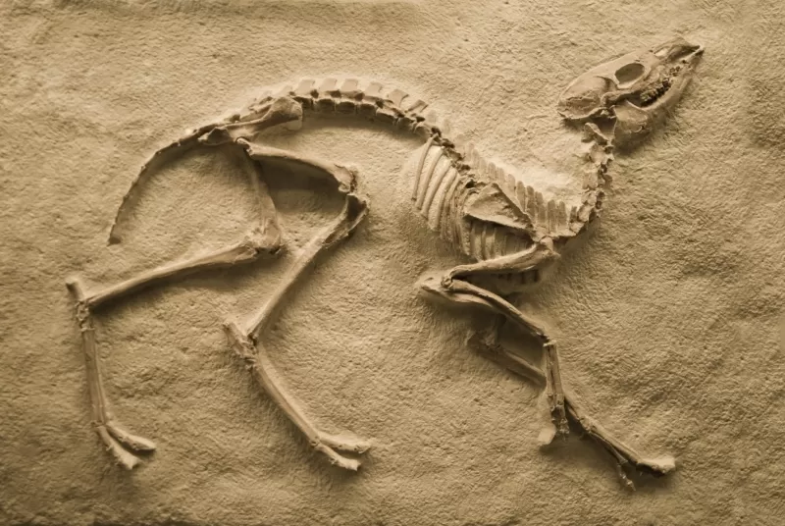
Science

This half term, our science topic is Rocks, Fossils and Soil. We will begin by grouping rocks based on their appearance and physical properties. We will then move on to explore the differences between sedimentary, metamorphic and igneous rocks and consider how these different rock types form. We will also be learning about the life and works of palaeontologist Mary Anning as well as investigating how fossils are formed. We will then investigate the properties and profiles of different soils.
After half term, we will be exploring the forces of push and pull as well as conducting experiments to explore friction. We will then learn about how magnets work, using the vocabulary of attract and repel. We will be investigating the strengths of different magnets as well as exploring which materials are magnetic.
Humanities
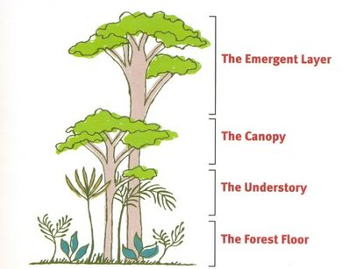
Our topic this half term is the Stone Age to the Iron Age. This is a history topic that begins the chronological teaching of British history throughout Key Stage 2. Whilst learning about prehistoric Britain, will be exploring how early humans survived and the challenges they faced. We will be considering the ways lives, houses and tools changed from the stone age through to the iron age.
After half term, we will be learning about the Tropical Rainforests. During this topic we will be using a range of maps and atlases to locate tropical climates and in relation to this we will be learning about the position and significance of the equator as well as the tropics of cancer and Capricorn. As well as learning about the physical geography of the rainforest and the different climates of the different layers. We will also be considering the human geography of the rainforest by discussing land usage and deforestation.

RE
In RE this year we will be learning about Christianity and Hinduism. This half term we will be focusing on the Hindu festival of Diwali and the question of ‘Do Religious celebrations promote a sense of belonging?’. After half term, we will be considering why Christmas is important to Christians and whether or not the meaning of Christmas is lost in festivities.

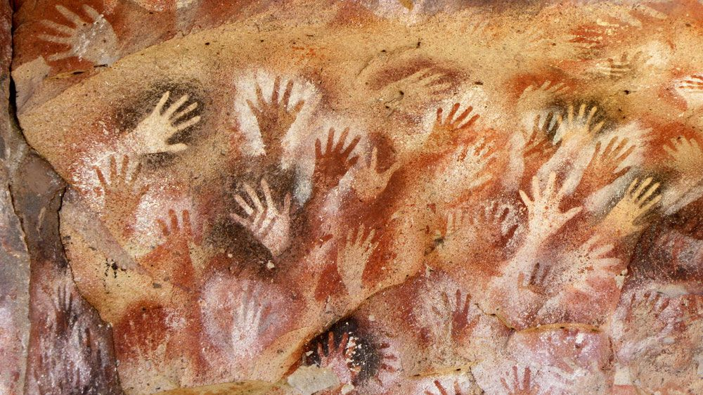
Art and DT
This half term, we will be working with chalk pastels within our art lessons. We will first begin by exploring the different effects created by different techniques when using chalk pastels, we will then use these techniques to create our own cave paintings inspired by photos of real life stone age cave paintings uncovered by archeologists. We will then learn to carefully blend colours when working with chalk pastels to form landscapes for a piece of Stone Age Silhouette art whereby we will carefully rip and tear paper to form our silhouettes.
After half term we will begin our first DT project of the year. We will be creating our own rainforest hand puppets. Children will begin by researching hand puppets, designing their own, making a prototype and choosing their materials. We will then cut out our templates and gather our materials before learning how to thread our needles and to use a running stitch to sew on any embellishments before sewing our hand puppets together. The children will then take part in an evaluation process during which they will evaluate their puppet against their original design.
Computing
In computing this term, we will be learning about computer systems, networks and connections. We will be learning about what a digital device is, how they function and how they change the way we work. We will also be learning to understand what an input and output is. We will then move on to learning about how digital devices are connected and how information can be shared through a network. Our E-Safety learning this half term is based on the topic of self image and identity. We will be considering what identity means and how people can represent themselves in different ways online and why this might be.
After Half term, we will be creating media animation during our computing lessons. We will begin by creating our own flipbook animations to understand that animations are sequences of drawings or photographs. We will then plan and create our own animations using digital technology. Our E-Safety learning after half term will be based around online relationships. We will be discussing the difference between knowing someone online and offline as well as understanding what information should not be shared online and why. We will also be considering how people's feelings can be hurt by information shared online and the importance of gaining/giving permission before sharing things online.
PE
In outdoor PE this term, we will be focusing on Invasion Games; specifically netball and tag rugby. We will be focusing on the skills of creating space, accurate throwing and catching and supporting our teammates as well as the importance of marking and basic principles of defending.
In indoor PE this half term we will be focusing on symmetry and asymmetry in Gymnastics. We will be exploring different balances and working with partners to create matching sequences containing symmetrical and asymmetrical balances. We will then adapt these sequences to create routines using gymnastics apparatus, travelling and different levels. After half term in indoor PE, we will be creating our own short dance motifs using cannon, mirroring, unison and improvisation. We will use the sounds, sights and animals of the rainforest as inspiration for our choreography and work on counting to the beat of the music and performing with an awareness of rhythm, expression, control and confidence.
PSHE
This half term, our PSHE learning is around the topics of respect and communities. We will begin by considering what a community is and the contributions made by different groups to a community. We will learn about the contributions different people make to a community and consider what diversity means and the importance of diversity within communities. We will consider the importance of respect and the impacts our behaviours can have on other people as well as the importance of self respect and what this means. After half term, we will move on to learning about the importance of positive friendships and the impacts of healthy and unhealthy friendships. We will learn to develop strategies to recognise and manage peer influence and a desire for peer approval.
Home Learning
In Year Three, home learning will consist of Reading, Times Tables, Spelling and an additional weekly task. Home learning tasks will either be set on google classroom or stuck in to their homework book. The children all have a log in to google classroom on a sticker in their school planner.
Homework is to be completed and submitted electronically or written in the homework book and handed into class by the due date.
Reading
Children in year 3 will continue to come home with a banded reading book to read at home. As well as a weekly library book.
We expect children to be reading aloud at home on a daily basis. Please fill in your child’s school planner when you listen to them read daily. As well as helping your child with fluency, expression and word reading, it is important to discuss the text with your child to check their comprehension and understanding of the text. Your child will have a reading question prompt sheet to help you ask your child appropriate questions to check their understanding in the back of their school planner.
Times Tables
The speed recall of multiplication and division facts is of great importance therefore we expect the children to complete daily times tables practice. Your child will be given a login for TimesTables Rockstars. 10 minutes of daily practice on this will help to improve the speed and accuracy of their recall.
Spelling
In Year 3, the children will have weekly spelling words to learn for a weekly spelling test. In the front of their homework book, there will be a variety of spelling homework tasks for children to choose from. The expectation is that they complete at least one of these activities as well as learning their spellings each week.
Please note: In weekly spelling tests, we will not only test words from that week by any of the words from the term.
New Spellings set on Fridays
Spelling homework due on Wednesdays
Spellings Tests on Fridays
English and Maths homework
Children will have either a piece of english or maths homework set on a weekly basis. This homework will either be stuck in your childs book or set via google classroom. Sometimes there will be the option to complete this homework either online or in the book.
New homework set on Fridays
Homework due in on Wednesdays

Please do not hesitate to ask if you have any questions,
Miss Findlay

