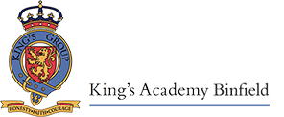
Welcome to Ruby Class!

September 2022

We have had a fantastic start to the year in Ruby Class, the children have settled so well and have made us very proud. They have all been very busy making friends, learning new routines and exploring their classroom. Our first topic is ‘It’s good to be me!’ where the children will think about how unique and special they each are as individuals. It has been great to learn all about the children so far and we look forward to getting to know each other even further as the topic progresses. Our Learning Support Assistant in our classroom is the wonderful Mrs Woad and we have both been blown away by how marvellous the children have been so far!
The Foundation Stage Curriculum is split into seven areas and some of the learning opportunities for this term are detailed below. The first three areas (PSED, Communication and Language and Physical Development) are called the Prime areas. These areas are particularly important for igniting children’s curiosity and enthusiasm for learning, forming relationships and thriving.

Personal, Social, Emotional Development
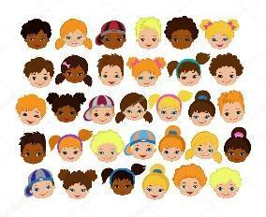
The first term of school is all about the children getting to know each other and feeling happy and safe in their new environment. We will be encouraging the children to be as independent as possible and welcome your support with this at home too. The children are learning to move around the classroom confidently whilst following the class rules. They will be exploring their feelings and how to express these and learning the importance of treating others, and their environment with respect. We will be encouraging children to show determination and resilience when facing challenges and most importantly, to approach their learning with a big smile on their face!


Communication and Language
There is so much talk in Ruby Class and all children will be encouraged to practise their speaking and listening skills through a variety of activities including whole class carpet sessions, group work, circle time and play. They will be learning to listen to others, develop their understanding of words and follow instructions. The children will be learning how to use their words to communicate their thoughts, wants and needs with the adults and children around them. The children will be developing new relationships, learning how to interact with each other and how to share resources in the classroom environment.

Physical Development
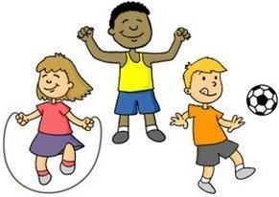
Throughout the year we will be focusing on both gross and fine motor skills. We have trikes and scooters in our garden and climbing equipment to encourage the children to travel over and under objects and have the opportunity to take risks. We will be using a range of resources to help develop fine motor skills such as playdough, threading, puzzles and arts and crafts. We will also be developing independence with tasks such as taking off coats, toileting, undressing/dressing and using cutlery correctly at lunchtime. Please continue to encourage your child to be as independent as possible with these tasks at home. The children will have weekly PE lessons on Tuesday afternoon and Wednesday morning with Mr Fisher, our primary PE teacher. During the lessons the children will be taking part in lots of fun listening and attention and movement games, to explore different ways of moving their bodies and developing their skills.

Literacy
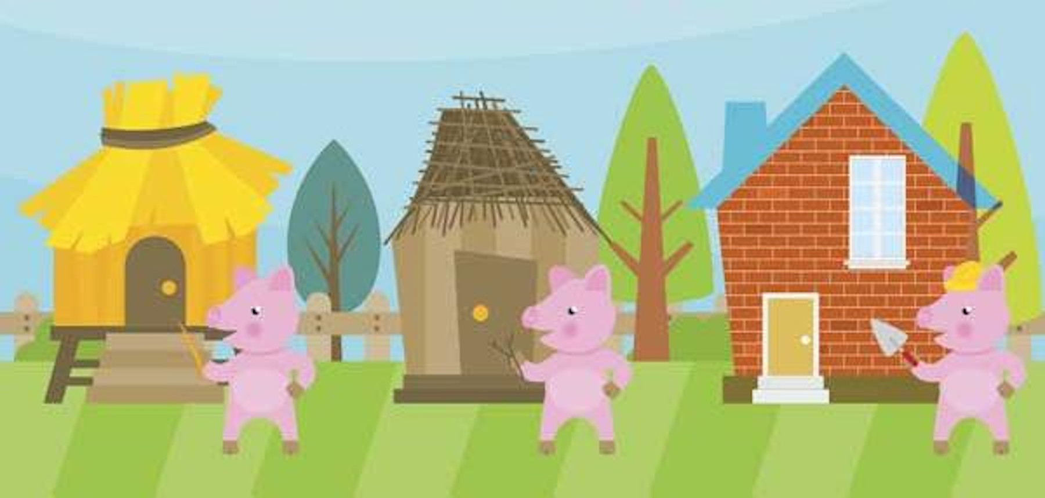
During this term we will be exploring lots of stories that will support our ‘It’s great to be me!’ topic such as ‘All are Welcome’ and ‘The Colour Monster’. We strive to foster a love of reading in the children and they will listen to wonderful stories every day that transport them to all sorts of exciting places! We will be singing songs daily to increase the children’s vocabulary and introduce them to rhyme. As an introduction to phonics we will be tuning in to different sounds in the environment and going for walks around the school to see what we can hear. The second half of the Autumn Term will be focused around Traditional Tales such as The Three Little Pigs and The Gingerbread Man. We will encourage the children to retell familiar stories using props and puppets and read the books independently by using the pictures to help them recall the events in the story.

Mathematics
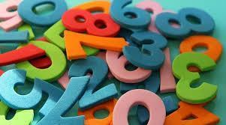
The children will be exposed to Maths daily. During free flow play the children will have the opportunity to explore numbers, counting, shape and many other mathematical concepts. The children will be practising to recite numbers in order, count objects accurately and recognise numbers. They will be exploring shapes and colours in the environment and making arrangements with objects. During carpet time we will begin exploring numbers to 5 and using number rhymes to help us develop our understanding of what numbers mean. Maths will be practical and fun!

Understanding the World

Ruby class will have lots of fun exploring the school and its surroundings. We will spend lots of time outside, exploring nature and all its wonders as we encourage and nurture curiosity in your children.

During this term, we will look at different celebrations and events including birthdays, Harvest, Diwali, Bonfire night, Remembrance Day and Christmas. If your family celebrates a special event, please let us know and we can talk about it in class.
We love having visitors in Ruby class so if you would like to come into school and share anything about your culture, religion or job to help better the children’s understanding of the world we would be very grateful and would welcome you with open arms.

Expressive Arts and Design
The children will have access to a range of creative resources which they can use throughout the day. We encourage the children to be independent in our creative area and develop their own ideas, selecting their own resources they would like to use from feathers and recycled bottle tops to string and tissue paper.
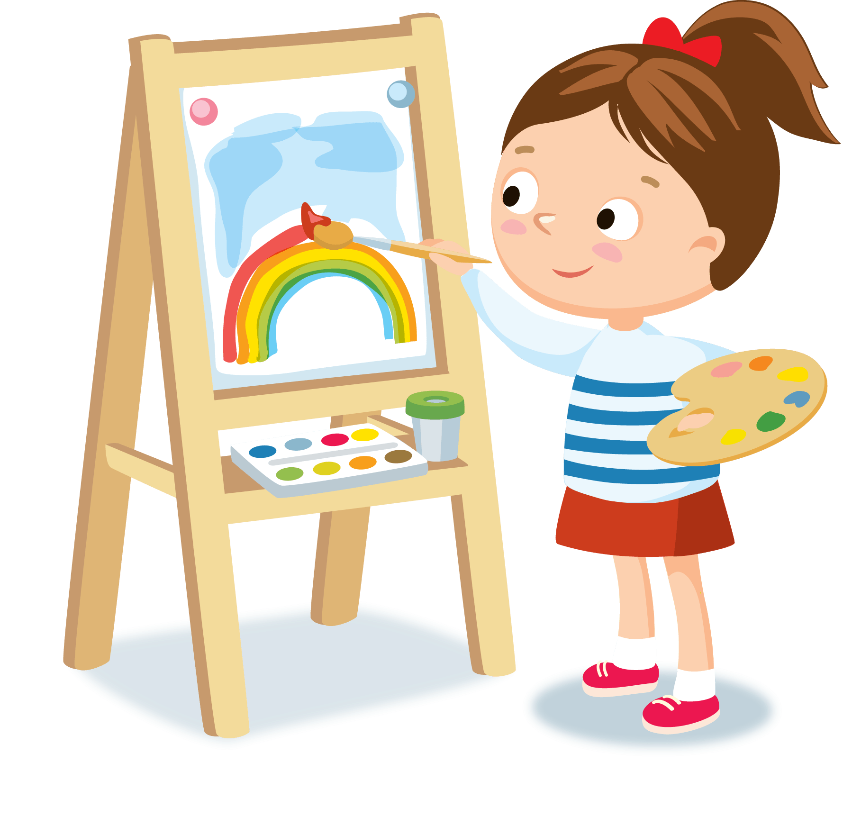
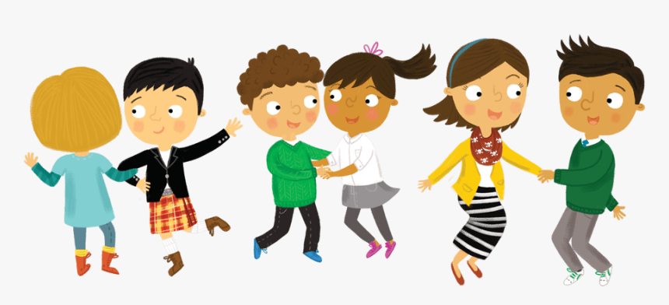
Imaginative role-play also plays a big part in the children’s play and learning. Our role-play area will be transformed into a variety of different scenes over the year depending on the children’s interests so they can draw upon their own previous experiences to develop their play. We will learn and share a variety of songs,there will be lots of singing and dancing in Ruby Class!

Star of the Week
Every Friday, one child will be chosen to be the star of the week. This is based on our school’s DARE values:
- Determination
- Aspiration
- Respect
- Enthusiasm

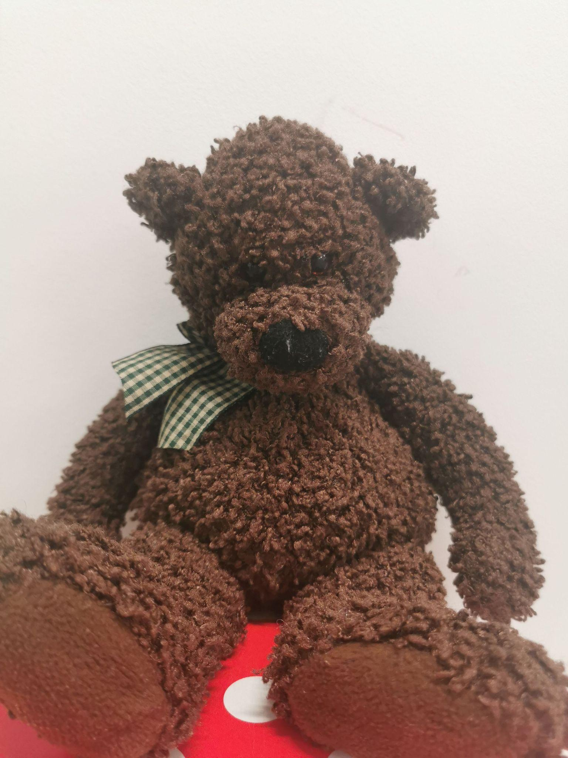
Ted the Bear
Our class bear, Ted, and his diary, will be sent home with the ‘Star of The Week’ every Friday. Each child will have the opportunity for Ted to stay with them for 5 whole nights! Please return Ted to school on Wednesday. In his diary, your child is free to draw, add photos and create a memorable diary entry which they can share with the class. There is no pressure to do anything out of the ordinary;Ted loves having bedtime stories, having picnics and playing at home too. We are looking forward to seeing Ted’s adventures!

Learning Journeys
Some of your child’s learning will be recorded on Tapestry, where you will be able to see what they have been busy learning at school. We welcome you to ‘like’ and comment on your child’s observations, for example, whether they have achieved something similar at home or if it is the first time. We also encourage you to add photographs of things your child has been doing, learning and experiencing at home. Your child will be given the opportunity to share these in class on our interactive whiteboard. An activation email will be sent to you shortly to sign up to Tapestry - look out for it and follow the instructions.
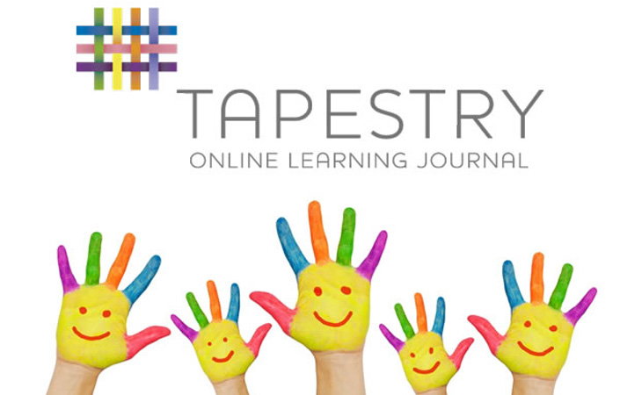

I will also send you a weekly ‘What we are learning’ page which will inform you of the themes and learning taking place in Ruby Class. This will enable you to develop and support your child’s learning at home as well as prompt conversations about what they are doing at school.
I am very much looking forward to sharing a fun and enjoyable learning journey with the children this year and also working in a supportive partnership with you.
Please do not hesitate to come and ask me any questions, my door is always open. Alternatively you can drop me an email at clare.greaney@kingsacademies.uk

Kind regards,
Miss Greaney
Nursery Teacher

