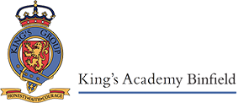
Welcome to Topaz Class!
Autumn 2022


The children have had a wonderful start to the school year and I have been very impressed with their strong, positive attitude to learning. It is a pleasure getting to know them and learning about all their amazing talents. I am looking forward to seeing all the great work that they will produce and I know we are going to have a fantastic year together!

English
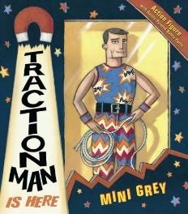
Writing
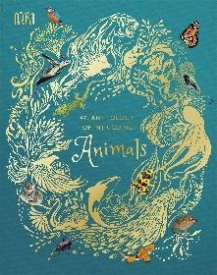
The children will be looking at a range of fiction and non-fiction texts as well as poetry this term. Key texts that we will be taking inspiration from include; Traction Man by Mini Grey, The Sound Collector by Roger McGough as well as non-fiction books on animals, and newspaper articles and diaries to link with our history topic after half term. Using these key texts, the children will take part in a range of modelled, guided, shared and independent writing activities to support their writing development. We will encourage the children to begin to write longer sentences including conjunctions and a range of descriptive language. We will consolidate what they learnt about simple punctuation last year and build on this so that the children are able to use a wider range of punctuation. Understanding how these different elements of language and punctuation can become their writers’ tools to become a more effective writer underpins our Year 2 English curriculum.
Reading, spelling and handwriting
The children have worked hard to learn their phonic sounds in Reception and Year 1. We can now develop that in Year 2 with daily guided reading lessons where we will continue to develop the children’s fluency and expression but also look at developing their comprehension of what they are reading, and expanding their vocabulary. The children will continue to have phonics lessons if they are needed and we will continue using what the children learned in their phonics lessons to support them with spelling. They will also now have more formalised spelling lessons with a low stakes quiz each week to encourage the children to begin to spell a range of words correctly following spelling patterns that they will learn in school. The common words that are exceptions to the spelling rules learnt in Year 2 are in the Key Stage 1 planner. Handwriting lessons will also be taught each week, we are focused on children forming letters correctly and with accurate sizing on the lines in their books i.e. small, tall and long letters.

Mathematics
Mathematics in the Autumn term of Year 2 focuses mainly on number and calculation. The children will be looking at place value, addition and subtraction as well as money. We will also begin looking at multiplication and division at the end of the Autumn term. You can support your child’s mathematics learning at home by:
- Practise counting forwards and backwards by playing games such as Snakes and Ladders.
- Count in 2s, 5s and 10s
- Learn to tell the time, initially to the o’clock and half past, then to the nearest quarter hour and then the nearest five minutes, as this will be a focus later in the year.
- Play card games to develop strategic thinking
- Play with money, looking at the values of coins and how to pay and get change.
In order to help your child at home, here are some of the ways in which addition and subtraction are taught in Year 2:
Addition
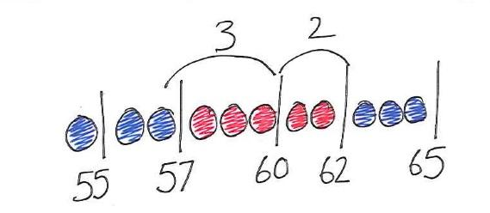
Counting on
Add any pair of 2-digit numbers by counting on in tens and then in ones, e.g.55+37 as 55 add 30 (85) add 7 (92)
Add 10 and small multiples of 10 to any given 2-digit number, e.g. 76+20 as 76,86,96 or in one hop 76+20

Using number facts
Number bonds – knowing all the pairs of numbers which make all the numbers to 12, and pairs with a total of 20
Patterns of known facts, e.g. 6+3=9, so we know 36+3=39, 66+3=69
Bridging ten, e.g. 57+5 as 57 add 3 then add 2 more

Add three or more single-digit numbers, spotting bonds to 10 or doubles e.g. 6+7+4+2 as 10+7+2
Using Place Value
Know 1 more or 10 more than any number, e.g.1 more than 67 or 10 more than 85
Partitioning, e.g. 55+37 as 50+30 and 5+7 finally combining the two totals: 80+12
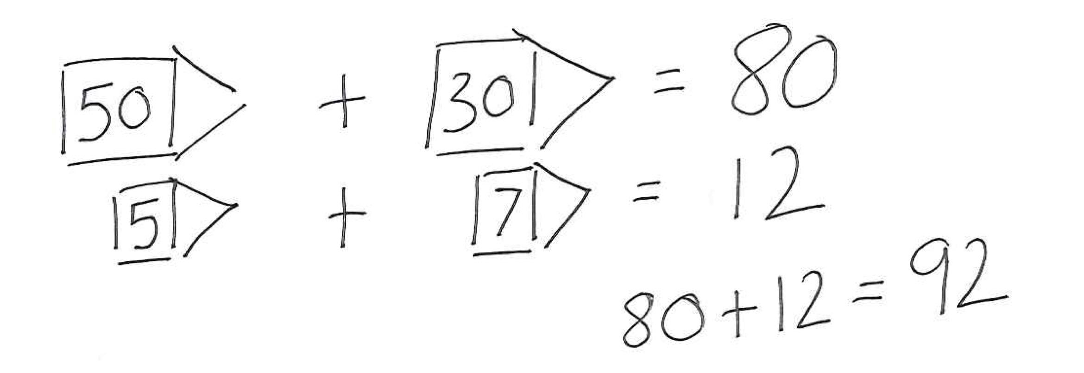

Subtraction
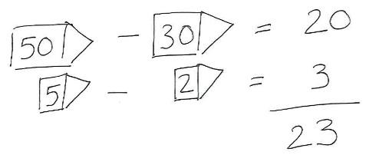
Using Place Value
Know 1 less or 10 less than any number, e.g. 1 less than 74 or 10 less than 82
Partitioning, e.g. 55-32 as 50-30 and 5-2 combining the answers 20+3

Taking away
Subtract 10 and small multiples of 10 from any given 2-digit number, e.g. 76-20 and 76,66,56 or in one hop
Count back in ones and tens from any given 2-digit number, e.g. 67-33 as 67 subtract 30 (37) then count back 3 (34)

Using number facts
Number bonds – knowing all the pairs of numbers which make all the numbers to 12
Subtract a single-digit number from any 2-digit number using number facts, including bridging multiples of 10, e.g. 52-6 as 52 subtract 2 then subtract 4 more
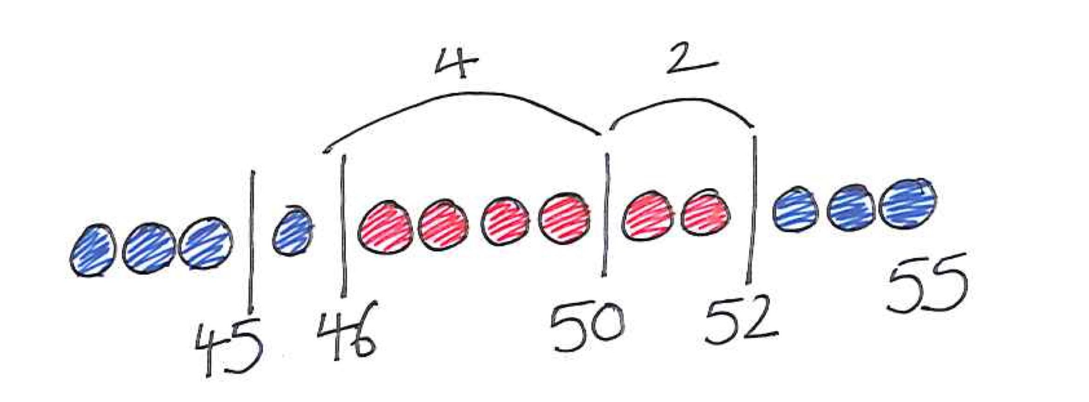
Counting up
Find the difference between two numbers on a line, e.g. 51-47

Science
The two science topics covered this term are ‘Animals, including Humans’ and ‘Uses of Everyday Materials’. Within the first science topic, the children will be learning about the basic needs for survival and thinking about how animals, including humans, grow and change from babies to adults. We will also be looking into the importance of exercise, healthy eating and hygiene.
Later on in the term we will be looking at everyday materials and their uses. The children will have plenty of opportunities to sort a range of materials in different ways, according to their properties and compare the suitability of everyday materials through investigations.

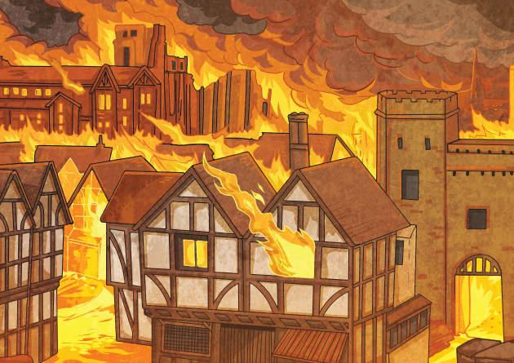
Humanities
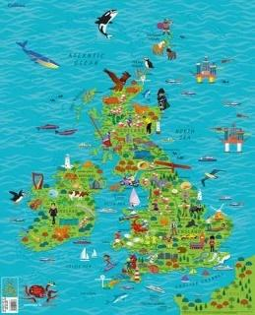
Our first history topic is The Great Fire of London. The children will learn about the causes and events of the fire. We will be using different sources such as Samuel Pepys’ diary entries to find out information and the children will be comparing and contrasting London and firefighting now and in 1666.
After half term our geography topic is called ‘On Our Doorstep’ where the children will be learning about the United Kingdom. We will be studying the characteristics of the four different countries of the UK and their capital cities. The children will be using basic geographical vocabulary and map skills.

Art and DT
In the first half term the children will be doing a unit of work on Art and Design called Exploring Colour. They will look at the colour wheel, colour mixing and the work of Wassily Kandinsky. Once they have finished this they will use what they have learned to create their own pictures of London during the Great Fire. After half term, the children will be doing Design and Technology, where they will be looking at different pop up card mechanisms and designing their own Christmas cards.
Computing
This term the children will be learning about computers and networks and the role that they play in our everyday lives. We will learn about the benefits of technology, but also how to use it safely. The children will begin to develop an understanding of how choices are made when using technology. We will also be looking at digital photography after half term, the children will be learning how to take, edit and change photos digitally.

Specialist teachers
The children will be taught Spanish, Music and P.E. every week.
Music
Music will be taught each week, exploring the importance of music around the world as well as learning the key musical skills of listening, composing and performing. The children will also be learning about different composers through our ‘Composer of the Fortnight’ series and their place in history.

Spanish
Spanish will be taught once a week over the term. The children will be building their cultural awareness of Spain and beginning to learn more about the country. Children will carry out a variety of interactive and fun activities to build their range of Spanish phonics and vocabulary.
Physical Education
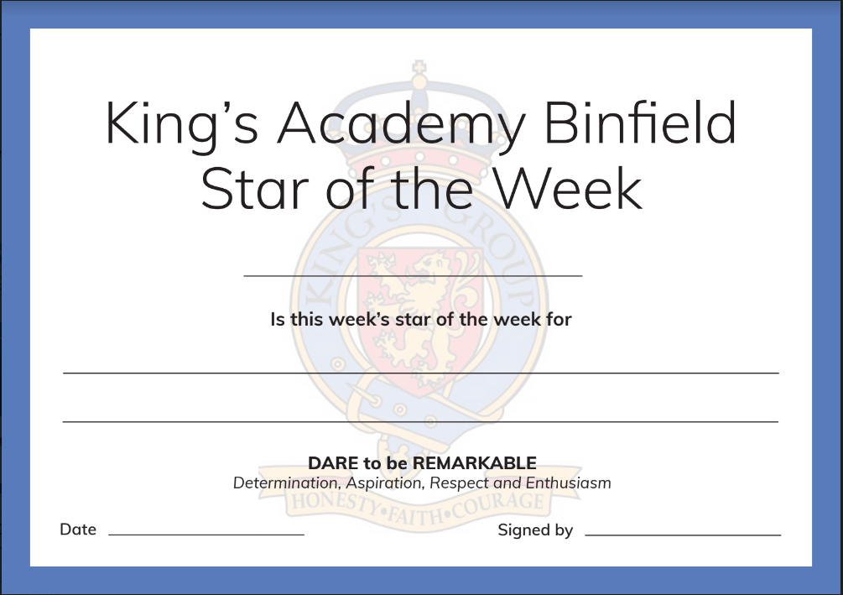
We are so lucky to have a new P.E. specialist teacher, Mr Fisher, who will be doing lessons this term supporting the children with their multiskills to build a good foundation for sports in Key Stage 2.
DARE Student of the Week
Every week I will be looking for outstanding examples of the school’s DARE values and I will be giving out a Star of the Week certificate to a child in the class who has consistently demonstrated one or more of the values throughout the week, this will be done in our whole school celebration assembly on a Friday.
Home Learning
Home Learning will be sent out on a Tuesday and should be handed in by the following Monday. Children are expected to read at home for 5-10 minutes every night and to bring their planner to school every day.
Children may have spelling words to learn and there will be a quiz on a Tuesday at school. They will have a ‘look, say, cover, write check’ sheet to practise with at home.
I am very much looking forward to sharing a fun and enjoyable learning journey with the children this year and also working in a supportive partnership with you.
Please do not hesitate to come and ask me any questions.

Kind regards,
Miss Kenney

