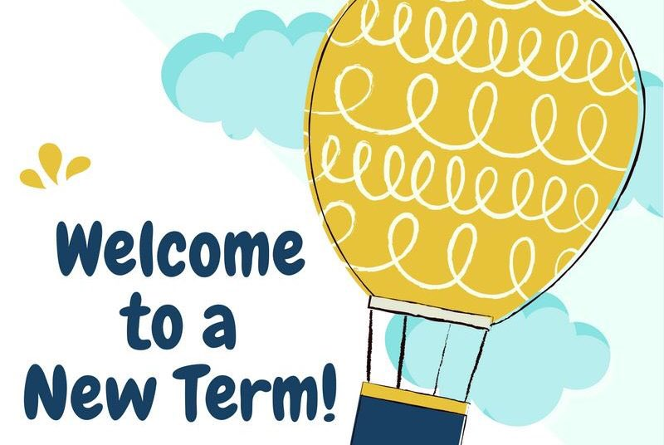
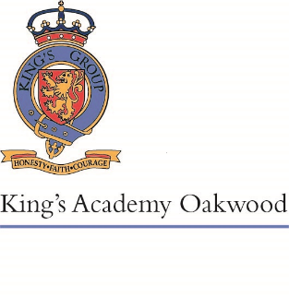

Pine Class
Autumn 2022

Welcome to Year 4! We are very excited to get to know you all and to start our learning journey together. Below, you will find an outline of the curriculum areas we will be covering in the different subjects this term, as well as information regarding home learning.
English
In English this term, we will be writing stories focusing on describing a character; we will begin by looking at how careful word choices can bring a character to life and help the reader to empathise with the character. We will also use our prediction skills to make up the ending to the story. We will then be going on to writing Non-Chronological reports linked to our science and history learning..
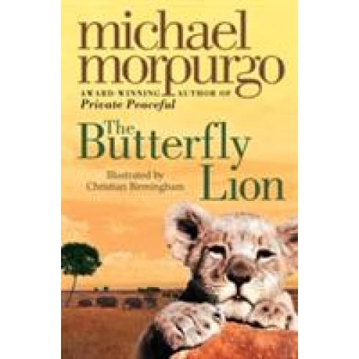
After half term, we will be exploring News Articles looking at text structure and formal language. We will then move onto explanation texts; inspired by Wallace and Grommit and their amazing contraptions. We will focus on writing in a logical order and varying our sentence structure. We will finish the term with some Christmas poetry and practise using expanded noun phrases.
Reading
This half term, in class we will be reading The Butterfly Lion by the wonderful Michael Morporgo and during guided reading we will be studying The Ironman by Ted Hughes. After half term, we will be reading the poetry book Love That Dog by Sharon Creech and in Guided reading we will be studying the Firework-Makers Daughter by Philip Pullman.
Maths
We will be starting our year’s maths learning with place value. A good understanding of the value of number is vital to all areas of maths so we will spend several weeks ensuring that everyone understands the value of all digits in a 4 digit number. We will practise adding and taking away 10, 100 and 1000 from any number and also rounding numbers to the nearest 10, 100 and 1000.
We will then apply our place value learning to a unit on addition and subtraction. Using both mental and written methods, we will practise adding and taking away 4 digit numbers and using inverse operation to check that our workings are correct. We will also use our rounding skills to estimate answers.
After this, we move onto measurement. We will revisit our units for measuring length: mm, cm, m and km and then apply this learning to converting units of measurement and measuring perimeter.
Lastly, we will be learning how to multiply and divide bigger numbers and explore what happens when we multiply and divide a number by 10, 100 or 1000. Good times table knowledge will help you enormously in this unit, so do keep practising your times tables at home.

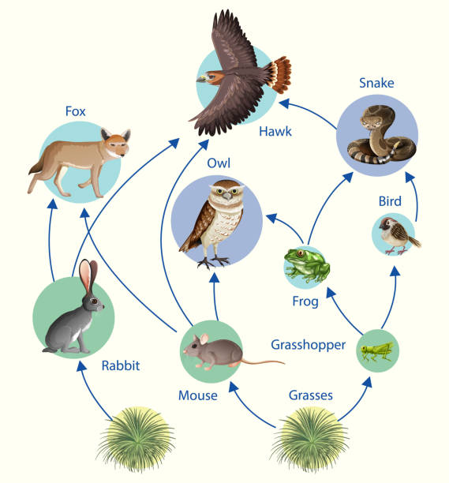
Science
In Science this term, our topic is Living Things and Their Habitats. We will be learning about food chains and using the terms producer, consumer and predator. We will learn how animals can be classified into groups and how animals are adapted to live in different environments. We will also be investigating what animals and insects live in our community.
After half term, we will be learning about states of matter. We will learn about different types of solids, liquids and gases, including solids which behave like a liquid! We will investigate reversible changes (like freezing water and melting ice) and irreversible changes (like bread becoming toast).
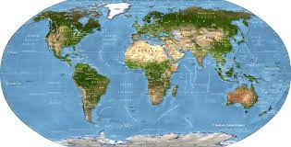
Humanities
This term, our History topic is Anglo-Saxons and the Scots. We will be learning about who they were, when they came to Britain and researching some of their most famous leaders. We will also be finding out why they came to Britain and learning about their art, way of life and their beliefs.
After the October half term, we will be learning about rivers and the water cycle in our Geography lessons. We will look at how the water cycle works and build on our science knowledge about water to include evaporation and condensation. We will also look at how water is useful, how it is stored and how it is treated so that it is safe to drink. Finally, we will learn how important it is to protect our rivers and water systems.
RE
This half term, we will be learning about Judaism and finding out how special the relationship is that Jews have with God. We will also find out about worship and whether this helps people to feel closer to God or their faith community.
After October half term, we will be learning about Christianity and what it is like for Christians to follow God. We will also find out about the most significant parts of the nativity story for
Christians today.

Home Learning
In Year Four, home learning will consist of Reading, Times Tables, Spelling and an additional weekly task. Home learning tasks will be set on Google Classroom or sent in the children’s books; the children will all have their google logins in the new school planners. Children will also be provided with a homework book so they can complete tasks either in there or electronically.
Homework is to be completed and submitted electronically or written in the homework book and handed into class by the due date.
Reading at Home
Children will continue to bring home a book from the Reading Scheme (if appropriate) or a book from the Year 4 suggested reading list as well as a weekly library book.
We expect children to be reading aloud at home on a daily basis. Please fill in your child’s planner when you listen to them read. As well as helping your child with fluency, expression and word reading, it is important to discuss the text with your child to check their comprehension and understanding of the text. There is some guidance on how to do this at the back of the school planner.
Times Tables
In year 4, all children have to do a national times table test. This is because the speed recall of multiplication and division facts is of great value to many areas of maths. Therefore, we expect the children to complete daily times table practice. Your child will be given a login for TimesTable Rockstars. 10 minutes of daily practice on this will help to improve the speed and accuracy of their recall.
Spelling
In year 4, the children will have weekly spelling words to learn for a weekly spelling test. There will be a variety of spelling tasks for children to complete each week to aid them in learning their spellings.
New Spellings set on Friday
Spelling homework due by Wednesday
Spelling Tests on Friday
English and Maths homework
Children will have either a piece of English or maths homework set on a weekly basis. This homework will be set via google classroom.
New homework set on Friday
Homework due in by Wednesday

Best Wishes,

Mrs Fitzgibbon and Mrs Grindley

