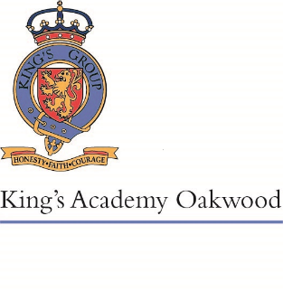
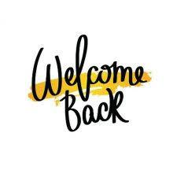

Welcome to Sycamore Class!
September 2022

We have had a wonderful start to the year in Sycamore Class, and I’m so proud of how well they have settled into Year 5. We have lots of fun activities and learning planned for you this term and we look forward to continuing to watch you develop.
English
In English this term, we will be writing newspaper reports focusing on using a variety of conjunctions, as well as quoting witnesses using both reported and direct speech. We will also be writing an adventure story based on our class text of ‘Shackleton’s Journey.’ We will be focusing on using atmospheric language, as well as combining grammar knowledge to create a gripping narrative.
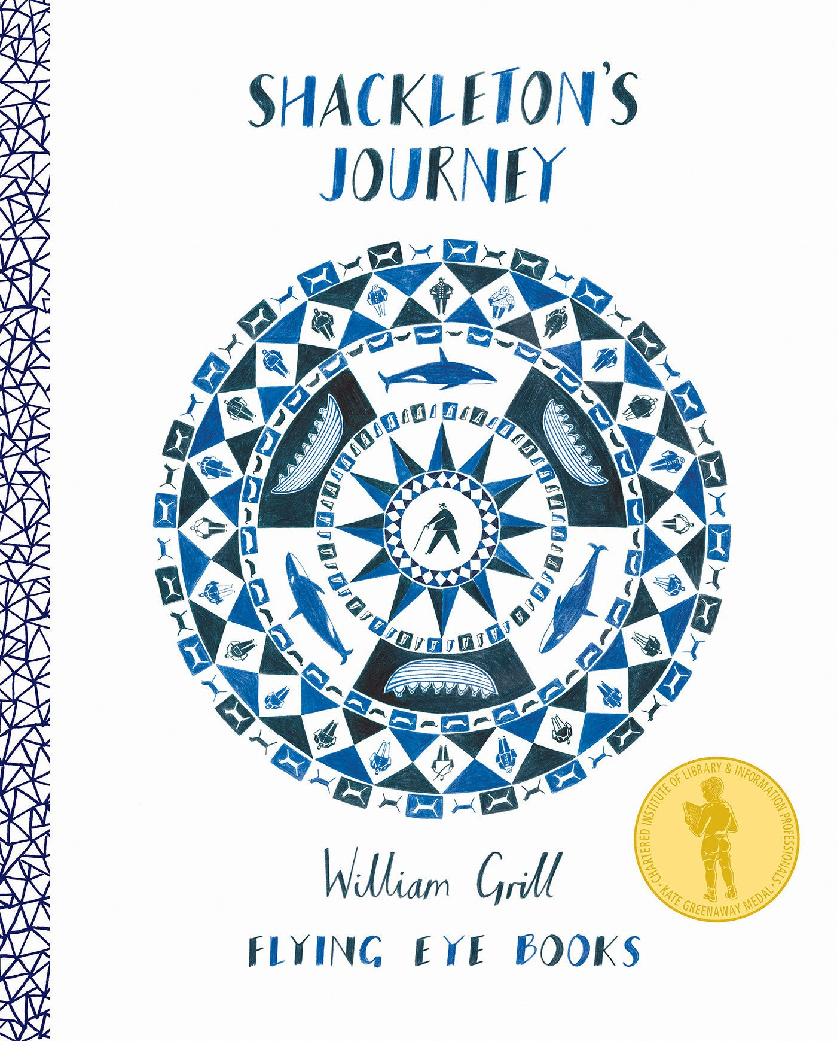
After half term, we will be working on setting descriptions and autobiographies linked to ‘Boy’ by Roald Dahl.
Reading
This half term, in class we will be reading The Hobbit and during guided reading we will be studying ‘Shackleton's Journey’; linked to our adventure story writing. After half term, we will read ‘Around the World in 80 Days’ as our class reader, and study ‘Boy’ by Roald Dahl.
Maths
We begin the term with recapping our place value knowledge; including representing, rounding and comparing numbers to a million, negative numbers and Roman numerals. Our second block is focusing on addition and subtraction, developing our understanding of using column method, using inverse operations to check answers, and multi-step problems.
After half term, we move on to learning about multiplication and division. This learning will be related to factors, square and cube numbers, and dividing by multiples. We then move on to measurement, with a focus on compound shapes, irregular shapes and rectangles,
Science
Our first science unit will teach us about forces such as gravity, friction, water resistance and air resistance. We will be learning how to identify forces, and looking at any patterns and links we can make between the weight of objects and the force of gravity. Once our foundations of forces are solid, we will work collaboratively to explore air and water resistance, participating in challenges to design the best parachute and boat. We will also have an opportunity to work in a hands-on way to explore fiction, by developing our own brake pad.
After half term, our topic will be properties and changes of materials. We will be learning about different materials, their uses and their properties. We will be sorting and classifying objects, as well as exploring the properties of materials most suitable for different purposes. The children will work scientifically to investigate the best thermal insulator to make a lunch box, as well as the best electrical conductor to make floodlights brighter.

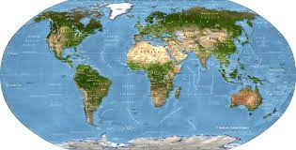
Humanities
This term, our Geography unit is Marvellous Maps. This allows us to further explore a range of maps available to geographers and develop our understanding of the key features of maps. We will study a range of maps, atlases and digital maps to compare features. We will also learn to use an eight-digit compass to give directions, and grid references to locate places precisely.
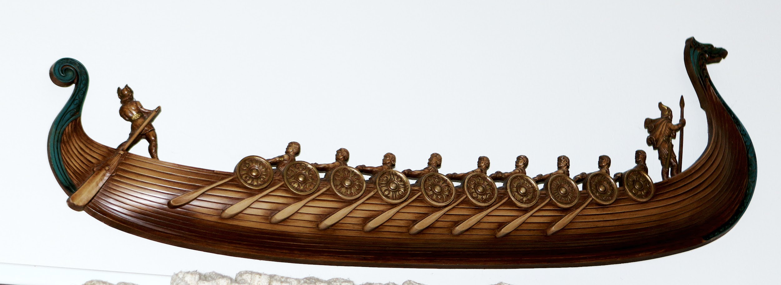
After the half term, our History topic will be Vikings following on from our Year 4 learning about Anglo-Saxons. We will be focusing our learning on the raids and invasions by Vikings in Anglo-Saxon Britain. Not only will we learn who the Vikings were, we will also learn about significant events from the time period and what the impact of the ‘Viking Age’ was.

Art and DT
Linking to our topic of forces in science, we will be further developing our understanding of mechanisms in DT. We will be designing and making a simple cam mechanism toy, using tools with accuracy for cutting, shaping and joining components together. Not only are we linking this project to science, but we will also be researching ideas relating to Antarctica and Shackleton’s journey on the Endurance to make our toys more appealing.
After half term, we will be having a food technology focus based on healthy snacks. We will be investigating the characteristics of cereal bars and why these might have been good for the crew on the Endurance to help with their energy and stamina.

RE
This half term, we will be learning about Sikhism. We will be learning about how far a Sikh would go for his or her religion, comparing different ways Sikhs put their religion into practice, and how these values transfer into everyday life.
After half term, we will be learning about the Christmas story, and asking the question ‘Is the Christmas story true?’

Home Learning
In Year 5, home learning will consist of Reading, Times Tables, Spelling and an additional weekly task. Home learning tasks will be set on Google Classroom or sent in the children’s books; the children will all have their google logins in the new school planners. Children will also be provided with a homework book so they can complete tasks either in there or electronically.
Homework is to be completed and submitted electronically or written in the homework book and handed into class by the due date.

Reading at Home
Children will continue to bring home a book from the Reading Scheme (if appropriate) or a book from the Year 5 suggested reading list as well as a weekly library book.
We expect children to be reading aloud at home on a daily basis. Please encourage your child to fill in their reading record every time they finish a book. As well as helping your child with fluency, expression and word reading, it is important to discuss the text with your child to check their comprehension and understanding of the text.
Times Tables
Your child can continue to use their login for TimesTables Rockstars. 10 minutes of daily practice on this will help to improve the speed and accuracy of their recall. Super Movers on BBC is also a good way to practise.
Spelling
Please ensure children are learning their spelling words each week which can be found on Google Classroom as well as in their Homework books.
New Spellings set on Friday
Spelling homework due by Wednesday
Spelling Tests on Thursday
English and Maths homework
Children will have either a piece of English or maths homework set on a weekly basis. This homework will be set via Google Classroom.
New homework set on Friday
Homework due in by Wednesday

Best Wishes,

Miss Bond

