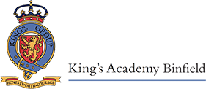
Welcome to Emerald Class!
September 2022
We have had a wonderful start to the year in Emerald Class and I am so proud of how well the children are settling. Their enthusiasm for learning is utterly infectious and they have shown such kindness to each other. They have all been very busy making friends, learning new routines and exploring their classroom and school.
Our first topic this term is ‘We’re all Wonders!’ and it’s been great getting to know more about each other and our unique personalities through this topic so far. What an incredible class family we are! Our Learning Support Assistant in our classroom is the lovely Miss Smith and she has also been blown away by how fantastic the children have settled into Emerald Class!
In the second half of the Autumn term, the children will be learning about Space in our ‘Look Up’ topic. I have no doubts that this topic will ignite great awe and wonder in your children!

The Foundation Stage Curriculum is split into seven areas and some of the learning opportunities for this term are detailed below. The first three areas (PSED, Communication and Language and Physical Development) are called the Prime areas. These areas are particularly important for igniting children’s curiosity and enthusiasm for learning, forming relationships and thriving.
Personal, Social, Emotional Development
The first term of school is all about the children getting to know each other and feeling happy and safe in their new environment. We will be encouraging the children to be as independent as possible and welcome your support with this at home too. The children are learning to move around the classroom confidently whilst following the class rules. They will be exploring their feelings and how to express these and learning the importance of treating others, and their environment with respect. We will be encouraging children to show determination and resilience when facing challenges and, most importantly, to approach their learning with a big smile on their face!

Communication and Language
There is lots of talk in Emerald Class and all children will be encouraged to practise their speaking and listening skills through a variety of activities like whole class carpet sessions, group work, circle time and play. They will be learning to listen and follow instructions and developing their ability to articulate their ideas and thoughts in well formed sentences. The children will learn a huge range of new vocabulary over the year including a weekly ‘Word of the Week’. We will let you know the words of the week in our fortnightly newsletter so that you can encourage your child to use these words at home and we hope you have great fun with them! The children will be developing new relationships, learning how to interact with each other and how to share resources with their new friends.

Physical Development
This term we will be focusing on both gross and fine motor skills. We will be using trikes, scooters and balancing equipment out in our garden and learning to travel over and under objects. We will pay a daily visit to our fabulous Trim Trail so the children can have fun climbing and taking risks! We will be using a range of resources to help develop fine motor skills like playdough, threading, puzzles and arts and crafts. We will also be developing independence with tasks such as taking off coats, toileting, undressing/dressing and using cutlery correctly at lunchtime. Please continue to encourage your child to be as independent as possible with these tasks at home. The children will be physically active every day and will have PE lessons twice a week on a Monday and a Thursday. Monday’s lesson will be taught by our PE specialist Mr Fisher. Your child may come to school dressed in their PE kit on these days. Please ensure they have their PE jumper with them and jogging bottoms if it is chilly!

Literacy
During this term, we will be exploring lots of stories, songs and rhymes, which the children can share, join in with and talk about. The children will begin to learn their phonic sounds using the Ruth Miskin scheme, ‘Read, Write Inc’. They will learn how to read and blend these sounds in cvc (consonant vowel consonant) words- it is just so exciting when they begin to start reading these words! As well as reading the sounds, they will learn how to form the letters correctly, using special rhymes to help remember. They will learn to recognise and write their name, using the correct pencil grip. We strive to foster a love of reading in the children and during daily storytimes they will be read a plethora of wonderful tales that transport them to all sorts of exciting places! We will read an engaging weekly text which the children’s literacy lessons will revolve around and as their phonic knowledge develops they will begin to write more and more! Individual reading books matched to your child’s phonic ability will be sent home during the second half of the Autumn Term- more details to follow. The children will visit our school Library every Tuesday to choose a wonderful library book to take home for the week. Please enjoy sharing your child’s library book with them and ensure it is returned to school on a Tuesday so they can choose a new one!
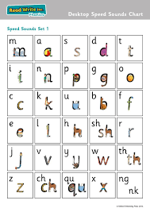

Mathematics
There will be daily opportunities for maths and above all it will be practical, purposeful, engaging and fun! We will begin the term by exploring positional language and we will complete our class calendar every morning to become familiar with days, dates and months. The children will practise matching and sorting, comparing amounts and comparing size, mass and capacity. We also will be exploring patterns all around us! Emerald Class will learn how to recognise, represent and compare numbers and how to identify one more or one less. We will begin to look at shapes and introduce time.

Understanding the World
Emerald Class will have lots of fun exploring the school and its surroundings. This term, we will look at and discuss seasonal changes and talk about ourselves and our families. We will encourage and nurture curiosity in your children. We love to hear their fabulous questions about the world around them! We will spend lots of time outside, exploring nature and all its wonders! During this term, we will look at different celebrations and events including birthdays, Harvest, Black History Month, Diwali, Halloween, Bonfire night, Remembrance Day and Christmas. If your family celebrates a special event, please let us know and we can talk about it in class. If you would like to come into school and share anything about your culture, religion or job with Emerald Class to help better their understanding of the world we would be very grateful and would welcome you with open arms.

Spanish
The Children will carry out a variety of interactive and fun activities whilst learning Spanish. They will learn greetings, numbers, colours and shapes. Olé!

Expressive Arts and Design
The children will have access to a range of creative resources which they can use throughout the day. Art skills will be taught over the term and creativity will be encouraged. Role-play will take place in the classroom and usually continues outside, being adapted by the children, according to their interests! Our role-play area will be transformed into a variety of different scenes over the year. We will listen to a variety of songs and the children will use percussion instruments to express themselves. There will be lots of singing and dancing in Emerald Class!

Star of the Week
I tell your children every day how much they amaze me and how proud I am of them, and although it’s always a difficult choice, every Friday in our celebration assembly, I will be choosing one child to be the star of the week. This is based on our school’s DARE values:
- Determination
- Aspiration
- Respect
- Enthusiasm
The children will also be able to collect DARE points for demonstrating these values during the school day – these count individually as well as for their house.
Penelope the Panda
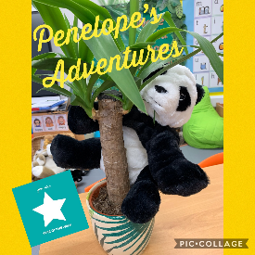
Our class panda Penelope, and her diary, will be sent home with the ‘Star of The Week’ every Friday. Each child will have the opportunity for Penelope to stay with them for 5 whole nights! Please return Penelope to school on Wednesday. In her diary, your child is free to write (you may want to scribe to begin with), draw and add photos in order to create a memorable diary entry. We are looking forward to seeing Penelope’s adventures!

Home Learning
Regular phonic practice will help consolidate your child’s learning in class. We will be holding a phonics meeting on Tuesday 20th September at King’s Academy Binfield to let you know all about the fantastic ‘Read, Write Inc’ scheme and how you can support your child with their phonics at home. After we have learnt a new phonic sound in class, we will send home a letter formation sheet for your child to practise at home. This letter formation sheet shows the special rhyme that your child has learnt to help them remember how to form the letter and we encourage them to say this rhyme as they are writing the letter. Please look out for these sheets in book bags. The sheets do not need to be returned to school. We really appreciate your support with helping your child with their phonics learning. Please continue to share books with your child and read to them as much as possible. Modelling reading and instilling a love of books in your child is so important and will support their learning immensely.

Learning Journeys
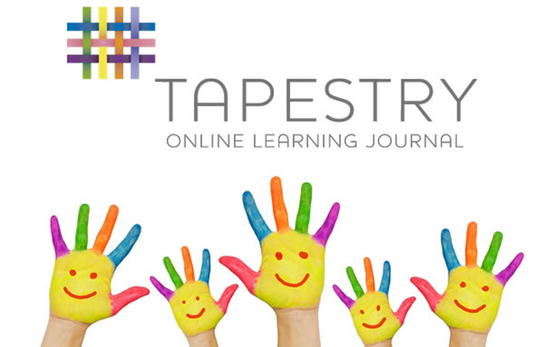
Some of your child’s learning will be recorded on Tapestry, where you will be able to see what they have been busy doing at school, an activation email will be sent to you shortly for this- look out for it and follow the instructions to activate. You can also add photographs and comments on to Tapestry- we would love to see what the children have been learning at home too.

It really is such an amazing privilege to teach your children for their first year of school and I am so looking forward to the year ahead with them and working in a supportive partnership with you.
Please do not hesitate to come and ask me any questions, my door is always open. Alternatively, you can drop me an email at naomi.mederson@kingsacademies.uk

Kind regards,
Miss Mederson
Reception Teacher
EYFS Lead

