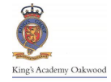
Welcome to Ash Class!
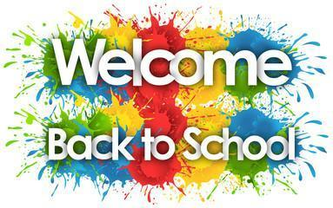
September 2022
I am very proud of the way that the children have started to settle into their new classroom environment. The children are managing the transition extremely well and we will continue to support them, socially and emotionally, as well as academically. In order for you to support your child at home, here is an outline of the different subject areas taught and the topics we will be covering within each area over the Autumn Term.

English
Phonics and reading
The children will have a daily phonics lesson which will include reading and spelling words with a new sound as well as revising sounds already taught. This is followed by a reading lesson that is focused on comprehension as well as decoding words with sounds they have learned (green words) and words that they have to learn because they are not decodable (red words).
Handwriting
Correct letter formation is a key focus in Year 1 and once the children are all able to form letters correctly, we will then start to look at the size and position of each letter. The Read, Write Inc. scheme that we use gives each letter a mnemonic device to help children remember how to form them.
Writing
The children will have a range of contexts through which to practise writing, using a wide range of both familiar and new high-quality picture books. Initially, the children will be looking at writing words in lists or as labels for a picture or photograph. They will learn and practise how to write sentences to caption an image, with finger spaces and full stops. They will use sound mats to help them apply their phonic knowledge and start to learn the Year 1 common exception words by heart. The children will learn to retell narratives and to think of sentences to match with the beginning, middle and end of a story.

Mathematics
This term the children will learn about place value to 10 and then 20, addition and subtraction and geometry.
- Practise counting forwards and backwards
- Say the number that is one more or one less than a given number
- Compare and order numbers using <, >, or =
- Recognising, naming and sorting 2D and 3D shapes
Addition
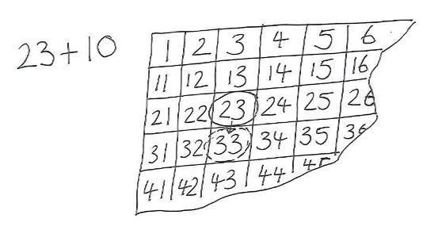
Using Place Value
Add 10 to any given 2-digit number e.g. knowing 45+1 or 45+10 without counting on in ones
Add by putting the larger number first
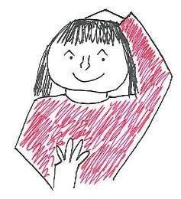

Counting on
Count on in ones from a given 2-digit number
Count on in tens from any given 2-digit number
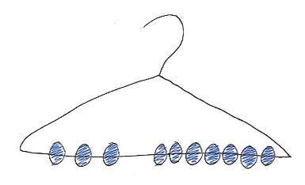
Add two single-digit numbers

Using number facts
‘story of’ 5, 6, 7, 8, and 9, e.g. 7=7+0 or 6+1 or 5+2 or 4+3
Number bonds to 10, e.g. 5+5, 6+4, 7+3, 8+2, 9+1, 10+0
Add three single-digit numbers spotting doubles or pairs to 10
Use patterns in number facts to add single-digit numbers to two-digit numbers, e.g. 4+3 to work out 24+3

Subtraction
Using Place Value
Subtract 10 from any given 2-digit number e.g. knowing 33-1 or 33-10 without counting back
Subtract one single-digit number from another
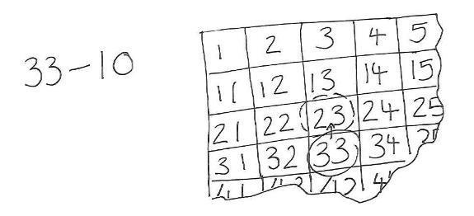
Taking away
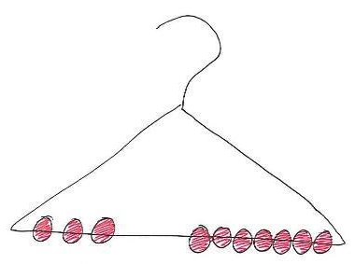
Count back in ones from a given 2-digit number, e.g. 11-3= or 15-4=
Count back in tens from any given 2-digit number, e.g.53-20 as 53, 43, 33

Using number facts
‘story of’ 5, 6, 7, 8, and 9
Number bonds to 10
Use number facts to subtract single-digit numbers from two-digit numbers, e.g. 7–2 to work out 27–2

Science
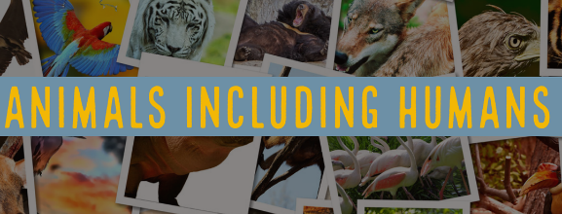
The Science topic covered this term is Animals, including Humans. In the first half term, the learning will be focused on our bodies, how people grow and change, and our senses. The children will be making observations, conducting simple experiments and increasing their knowledge.
The second half term of teaching will focus on the weather and seasons. We will focus on Autumn for the first half and Winter for the second half. We will explore Spring and Summer later in the school year.

Humanities
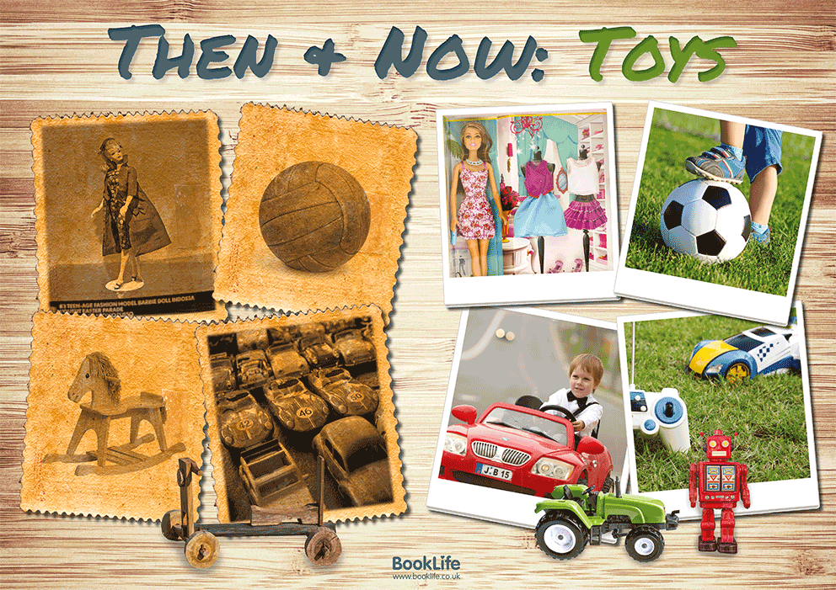
The first topic this term is a geography topic based on our local area. The children will be looking at maps on different scales from a bird’s eye view of a classroom, the school and its grounds and the area around school. The children will learn to use simple compass directions and directional language.
After half term, in history, the children will be learning about the history of toys. Looking at how toys and games have changed since the beginning of the 20th Century. This will support them with the development of key historical skills such as comparing and contrasting, using their knowledge to order objects on a simple timeline. This offers excellent cross-curricular opportunities as the children make their own puppet in D&T.

Physical Education
The children will be completing a variety of exercises and gymnastic routines that will enable them to have more self-awareness of their body and their surroundings. The children will be taught by a specialist teacher once a week, focussing on learning and practising the basic skills of throwing and catching, developing these skills to play games.
Later on in the term, we will be focussing on dance where the children will create a sequence of moves linking to our ‘Santa’s Elves and Toys’ topic. We will also be learning and taking part in some attacking and defending team games.

PSHCE and Life Skills
This term in PSHCE, we will be using a variety of stories to discuss right and wrong choices in addition to knowing what a secret is. After half term, we will be focusing on how to play together appropriately and co-operatively.

Art and Design Technology
In art, we will be studying a range of artists such as Andy Warhol and creating our own self-portraits. Later in the term, along with our ‘History of Toys’ unit, in design technology the children will make their own puppets from scratch.

Computing
The children will begin the year with programming; using beebots to plan a simple sequence of commands and debug any problems that arise. We will then move onto learning basic computer skills such as logging on and off, typing and using a trackpad.

Music
Music will be taught each week, exploring the importance of music around the world as well as learning the key musical skills of listening, composing and performing. The children will also be learning about different composers through our ‘Composer of the Fortnight’ series and their place in history.

Spanish
Spanish will be taught once a week over the term. The children will be building their cultural awareness of Spain and beginning to learn more about the country. Children will carry out a variety of interactive and fun activities to learn the different colours in Spanish.

Home Learning
This half term we will be setting the children a task; to collect 3 items/photos from home to bring into school and ‘show and tell’ to the rest of the class. As an idea, these could be a photo of their family or a pet, an item related to a hobby or anything that they would like to talk to the class about. Each child will be given a date over the first half term so they know when to bring in their ‘all about me’ bag.
Each week the children will bring home 3 types of books:
- Every Friday your child will bring the book they have read in school that week home over the weekend to show off how well they can read it. These books must be returned to school on Monday morning.
- Your child will also bring home a reading book which can be changed each day in school or as often as needed. At this stage re-reading books can be helpful for developing fluency and comprehension.
- Finally, your child will have the opportunity to borrow a library book each week.

Star of the Week
Each week, I will be choosing one or two children to be the star (or stars) of the week. This is based on our school’s DARE values:
- Determination
- Aspiration
- Respect
- Enthusiasm
The children will also be able to collect DARE points for demonstrating these values during the school day – these count individually as well as for their house.
I am very much looking forward to sharing a fun and enjoyable learning journey with the children this year and also working in a supportive partnership with you.
Please do not hesitate to come and ask me any questions, the door is always open.
Kind regards,
Mrs S Wright, Year 1 Class Teacher
Letter formation mnemonics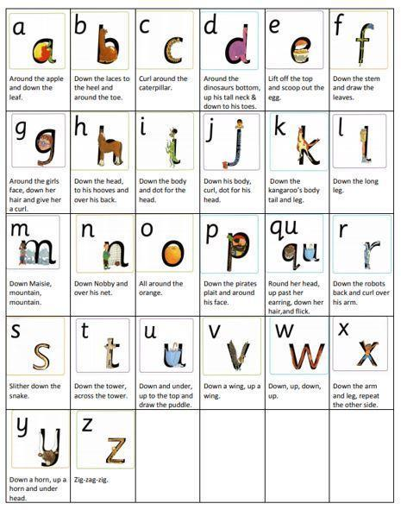

Year 1 Common Exception Words

These are the words that children are taught to read and spell by the end of Year 1, they have been organised into manageable groups on the table below.

a | is | said | be | no | put
ask | his | says | he | go | push
 | has | the | me | so | pull
are |  | they | she |  | full
our |  | there | we | of | one
 | was | here |  | love | once
do | were | I | by | come | school
to | where | you | my | some | friend
today | want | your |  |  | house

